**Microprocessor and Computer Architecture**

**UE20CS252**

**4th Semester, Academic Year 2021-22**

Date: 24/1/2022

|  |  |  |
| --- | --- | --- |
| Name: VISHWAS M | SRN: PES2UG20CS390 | Section:  F |

Week#____2_______ Program Number: ____1___

Title of the Program

**Write an ALP using ARM instruction set to check if a number stored in a register is even or odd. If even, store 00 in R0, else store FF in R0**

1. ARM Assembly Code(1)
2. Output Screen Shot (1)

The output should be verified for both even and odd numbers.

1. Output table (1)

**I.CODE:**

**.text**

**MOV r1, #8**

**ANDS r2,r1,#1**

**BEQ L1**

**MOV r0,#0xFF**

**B L2**

**L1: MOV r0, #0x00**

**L2: SWI 0x011**

**.end**

**II.SCREENSHOT:**

**a)for odd number:**

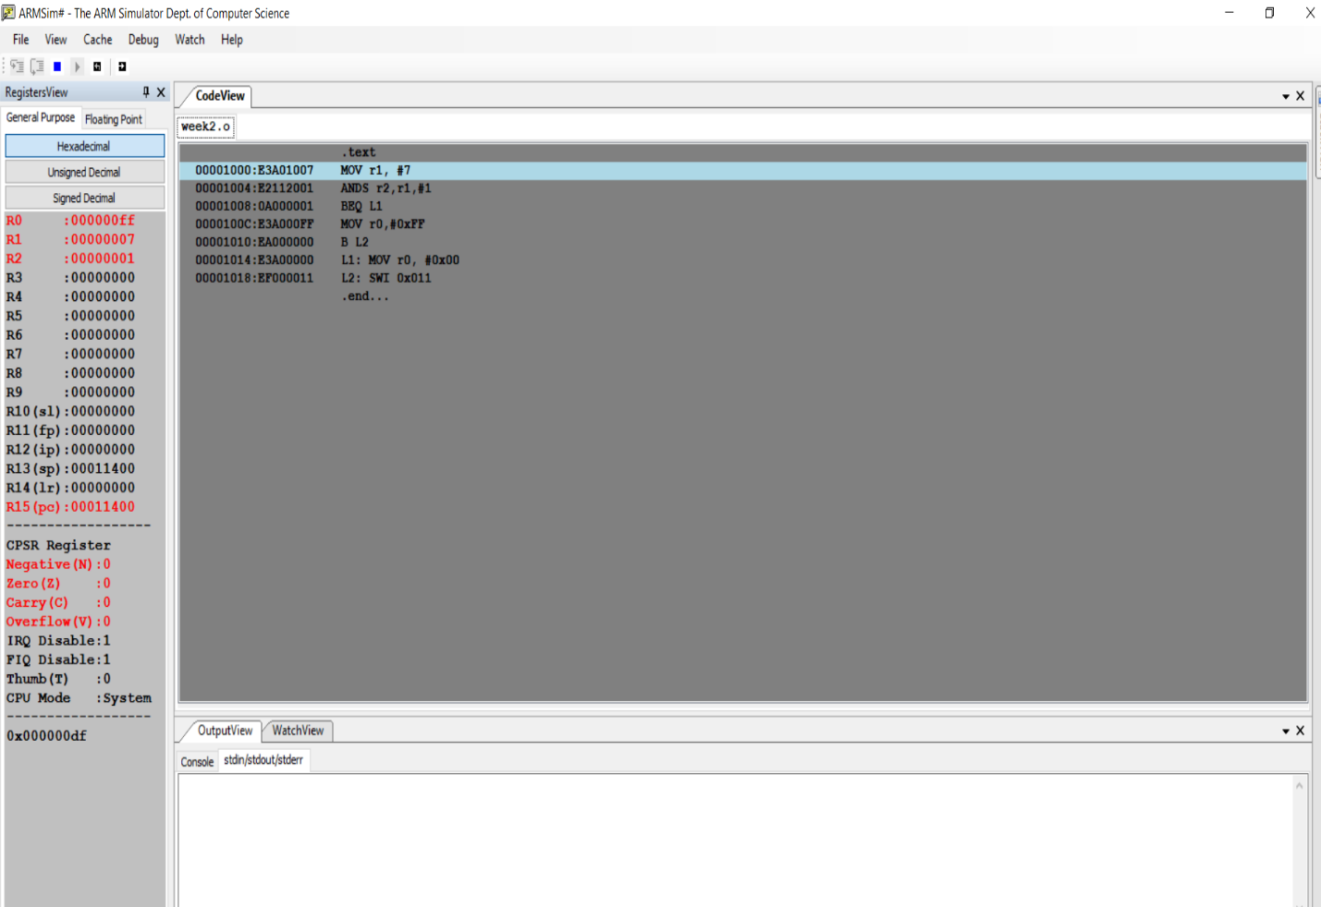

**b)for even number:**

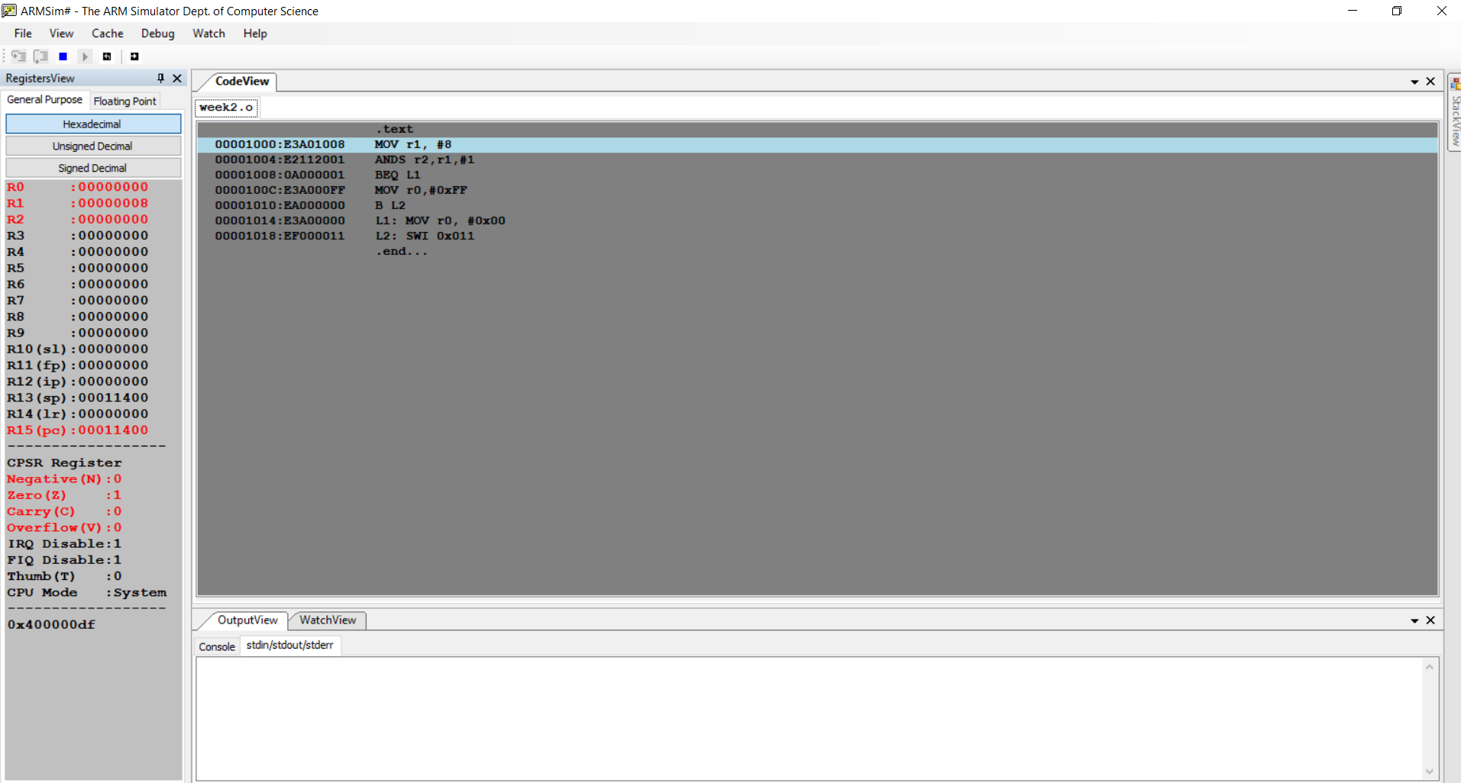

**Microprocessor and Computer Architecture**

**UE20CS253**

**4th Semester, Academic Year 2021-22**

Date:

|  |  |  |
| --- | --- | --- |
| Name: VISHWAS M | SRN:  PES2UG20CS390 | Section  F |

Week#____1_______ Program Number: ____2___

Title of the Program

**Write an ALP to compare the value of R0 and R1, add if R0 = R1, else subtract**

**I.CODE:**

**.text**

**MOV r0,#7**

**MOV r1,#7**

**CMP r0,r1**

**BEQ L1**

**SUB r2,r0,r1**

**B L2**

**L1:ADD r2,r0,r1**

**L2:.end**

**II.SCREENSHOT:**

**a)for different numbers:**

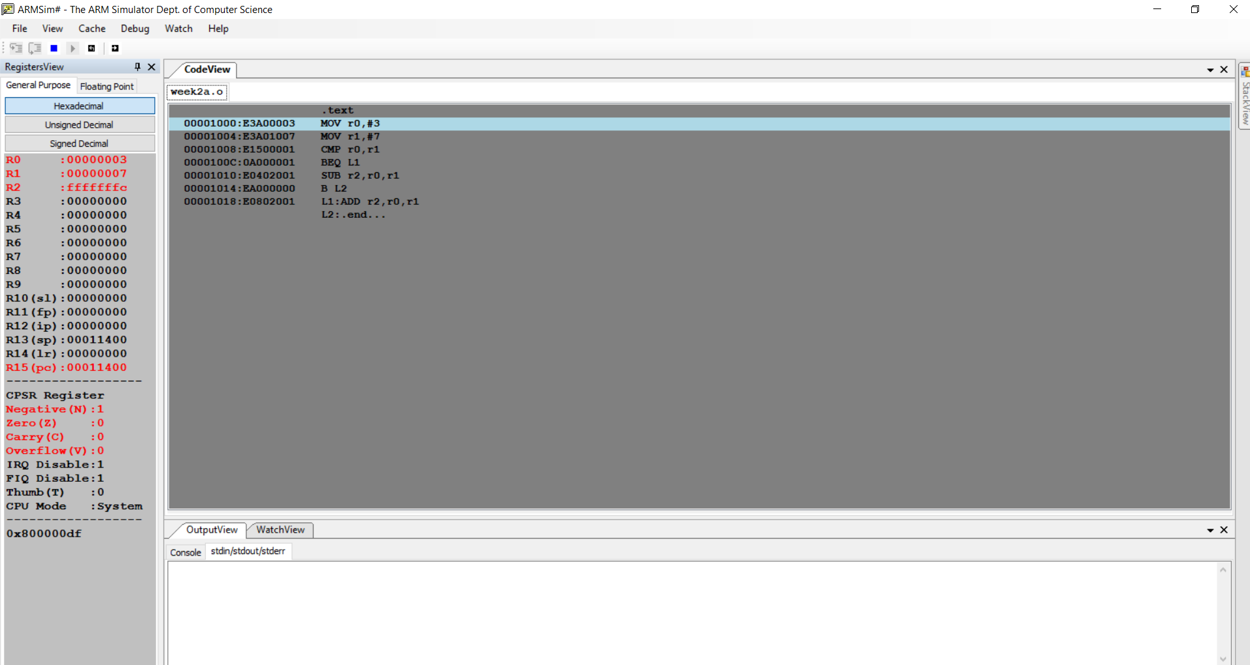

**b)for same numbers:**

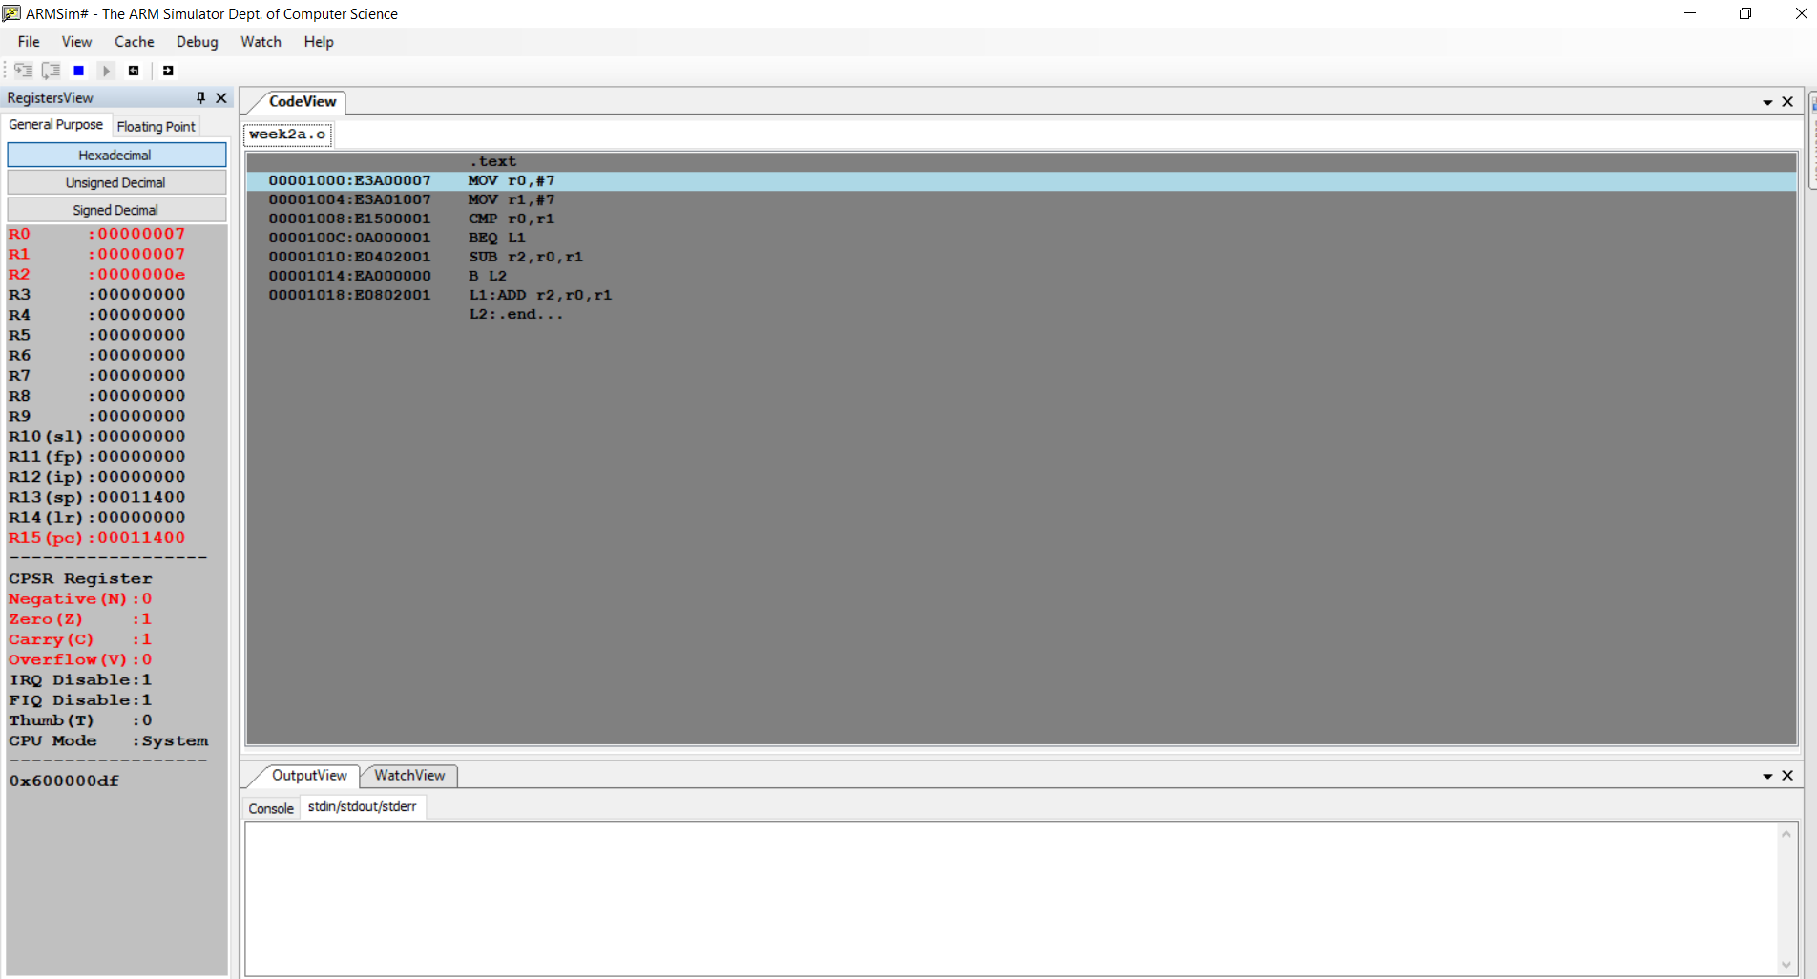

**Disclaimer:**

* The programs and output submitted is duly written, verified and executed by me.
* I have not copied from any of my peers nor from the external resource such as internet.
* If found plagiarized, I will abide with the disciplinary action of the University.

Name: Vishwas M

SRN: PES2UG20CS390

Section: F

Date: 24-01-2022